Design of multiband MIMO Antenna

3-slot based Circular patch antenna

# Anshika Shrivastav

*Electronics and communication Engineering,*

*NIT Warangal*

[anshikashrivastav28@gmail.com](mailto:anshikashrivastav28@gmail.com)

# Dr. [Amarjit Kumar](mailto:amarjitk@nitw.ac.in)

*Electronics and communication Engineering,*

*NIT Warangal*

amarjitk@nitw.ac.in

# Pradeep Kamal

*Electronics and communication Engineering,*

*NIT Warangal*

[PRADEEP KAMAL](mailto:pkamal@student.nitw.ac.in)

# Yash Deshmukh

*Electronics and communication Engineering,*

*NIT Warangal*

[Yash Deshmukh](mailto:ydeshmukh@student.nitw.ac.in)

***Abstract*——**

**A Multiband MIMO for future 5G communication application is introduced in this paper.The single element used in MIMO configuration is a circular microstrip antenna. To obtain multiband and improved bandwidth , the patch antenna is loaded with slots. In this work, we have loaded a circular patch antenna with T-shaped slots. The single element has a small size, with a radius of circular patch equal to 3.2mm. The dielectric substrate used is Rogers RT-5800 with dielectric permittivity of 2.2 and loss tangent of 0.0013.The dimensions of dielectric are 10mmx10mmx0.72mm.The MIMO antenna has tri-bands. The operating frequencies are 27.465GHz, 35.584GHz and 49.676GHz.**

***Index Terms*—MIMO,ECC,VSWR, mm-Waves,circular patch antenna.**

1. INTRODUCTION

The demand for high data rates is increasing every day with new applications such as IoT, autonomous cars, Augmented reality etc emerging. Moreover, the upcoming communication technology will have to support a variety of different devices than what exists today. As a result, 5G has attracted a lot of attention. It is expected to be a breakthrough technology.5G is expected to support a very high data rate, have ultra-low latency, wider bandwidth and a huge diversity of applications and devices. It will have data rates up to 10 Gbps [6]. The mobile data traffic generation will not be limited to video streaming, pictures, audio-only but extend to social media applications, cloud services, IoT, Artificial intelligence devices etc.

Developing new technology with higher data rates and higher bandwidth is itself a very challenging task. This is mainly because the existing spectrum has become almost completely occupied. Currently, terrestrial wireless systems utilize a portion of microwave frequencies that ranges from MHz to a few GHz. This is a relatively slim spectrum and often called the beachfront spectrum. However, luckily there is a good amount of free spectrum in the millimetre range which extends from 30-300GHz. The wavelength here is 1-10 mm[1]. This free spectrum in millimetre wave frequency can support larger bandwidth which consequently will result in a higher data rate. The present 4G supports 20 MHz channels, however, with higher bandwidth 5G can provide comparatively much higher data rates.

As the number of users and devices increases, there will be a steep rise in traffic. As a result, more antennas (access points) will be required in the future generation of communication networks. Transmission and receiving of signals are done through antennas, hence, they are very important. A good antenna will ensure a good communication system. Thus, designing an antenna plays a dominant role, at both ends. Multiple-input-multiple-output antennas are used at both sending and receiving ends. This provides spatial multiplexing, thus higher data rates, link reliability and spectral efficiency. Hence, MIMO technology is an essential requirement for the development of 5G technology [13]. The key features of MIMO are spatial multiplexing, enhanced data throughput and high data integrity due to path diversity, and beam steering/beamforming techniques [15]. Consequently, the Multiple Input Multiple Output Antenna plays a major role in making 5G a reality. Characteristics of an ideal 5G antenna are high gain, compact designs, very low return loss, high efficiency, and very low ECC to meet the 5G technology requirements which include massive throughput, blazing speeds, capability and ultra-low latency.[9]

Since 5G systems will use millimetre wave bands, the antennas will be required to have high gain in order to compensate for atmospheric losses due to absorptions and diminutions.[12]Moreover, they will support wider bandwidth. The path loss is significantly high in the millimetre wave spectrum thus MIMO is essential to provide improved gain. [4]Since MIMO uses multiple antennas for both transmission and reception, they need to be designed and placed in such a way that the mutual coupling between antennas is the least. The high mutual coupling will affect the radiation pattern of the antenna. Reducing mutual coupling becomes more challenging when the size is required to be compact. Additionally, just reducing the size of the antenna is also not possible as it will affect antenna performance such as efficiency and operating bandwidth. All these will affect the diversity performance of MIMO systems. Thus there is a tradeoff between antenna size and performance metrics. The challenge is to optimize all parameters for best performance keeping in mind the design constraints.[8].Good isolation between antennas of MIMO configuration is required to provide independent paths for communication channels. The most difficult challenge thus remains to develop MIMO in a compact size with good isolation[11].

We have used circular microstrip antennas to obtain multiband MIMO antennas for 5G applications.Patch antenna contains a dielectric substrate, ground, microstrip feed and patch which can take many shapes like triangular , circular, rectangular etc. Addition of slots in original structures can add additional operating frequency bands, improve bandwidth and return loss.Moreover, it helps reducing the size.

1. ANTENNA DESIGN

*A. Antenna Design Procedure*

The first step to design a multiband MIMO antenna is to design its single element structure.We have selected a circular patch antenna to work it. Hence first the dimensions of this patch antenna are determined. Once the basic circular antenna is designed, the next step is to load it with slots to obtain multiband frequencies of operation and improved bandwidth with improved return loss.The slots are loaded in a circular antenna and simulation carried out. At this step we tried many different slot shapes such as T-shaped, U-shaped, star shaped, rectangular slots etc. Finally the antenna with the best parameters was selected. The next step involved utilizing this single element in MIMO configuration. The main requirements here are good isolation between the antenna , otherwise the radiation pattern gets affected. Various configurations were analyzed to find one having maximum isolation between the single elements.Once the configuration is done, simulations run to check if they give the required parameters.This is the final step.Thus if all requirements are satisfied, the design is finalized.

While designing, it is necessary to choose a substrate of lesser relative permittivity for good radiation efficiency.A thicker dielectric may result in wider bandwidth. Thus Rogers RT-5800 with dielectric permittivity of 2.2 and loss tangent of 0.0013 chosen as our substrate.Radius calculated with the above formula for our desired frequency. Since we are looking to design antenna for 5G application, we have to choose frequency in mm-Wave spectrum.[22][23]

*B.Single element Design*

The radius of circular microstrip antenna can be found using the following formula [16] :

here

f: resonant frequency

ε: relative permittivity of the dielectric

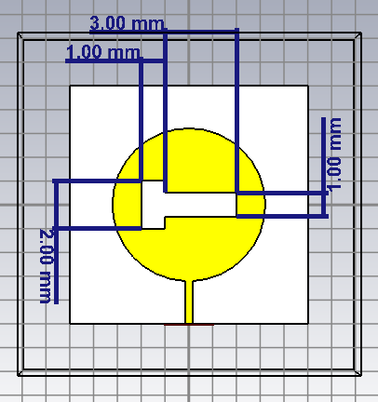

Figure 1: Proposed single element design

The circular patch antenna is loaded with T-shaped slot as shown in figure -1. The size of two side slots are the same but different from the dimensions of the centre slot.The thickness of substrate is 0.72mm. The dimensions of the ground plane are 10mmx10mm and radius of circle is 3.2mm.

*C.MIMO Configuration*

Once single element design is finalized, it is placed in the MIMO configuration .We have used 4 single element antennas in MIMO antenna.Different configurations were designed and analysed to find the best one. Various configurations tested included linearly arranging all elements side by side, placing 2 ports down and other 2 up opposite to them and one where all ports were in different directions.

The configuration where all ports were in different directions gave the best results in terms of isolation of antennas.

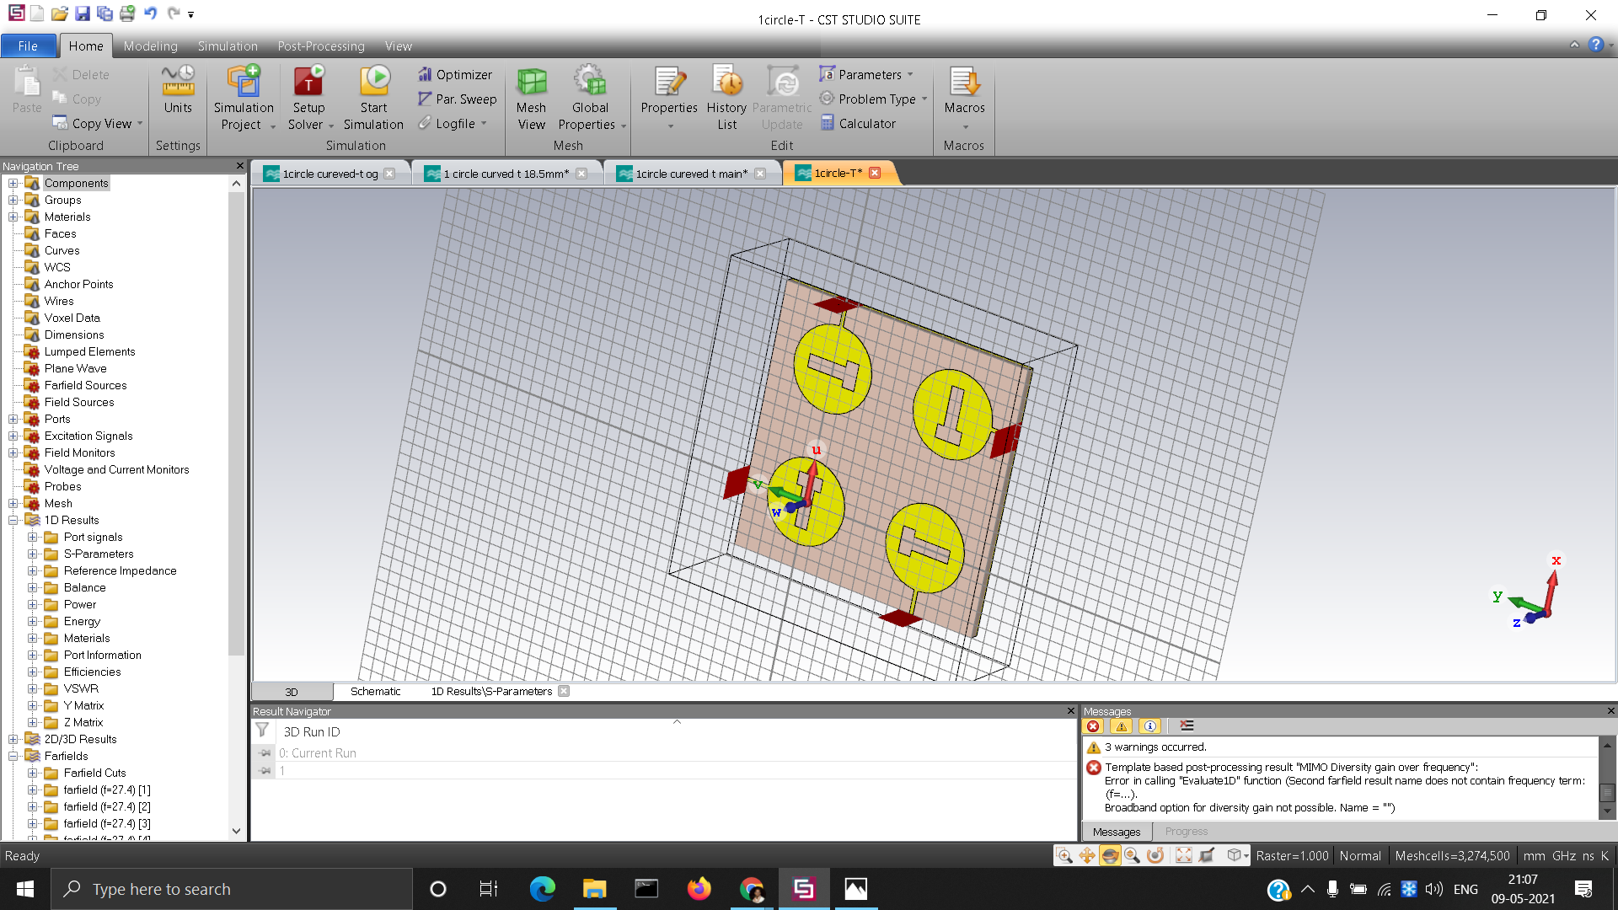

Figure 2 : MIMO antenna.

Thus the radiation pattern of individual elements was not disturbed. Figure 2 shows the configuration of 4 antennas which provided best results in terms of isolation. As mentioned earlier, here all ports are in the opposite direction from each other.

1. SIMULATION RESULTS
2. *S-parameter*

Figure 3: return loss v/s Frequency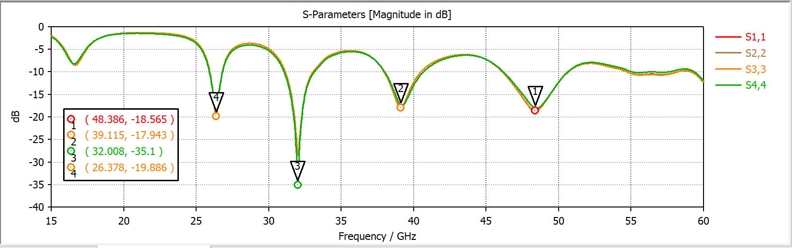

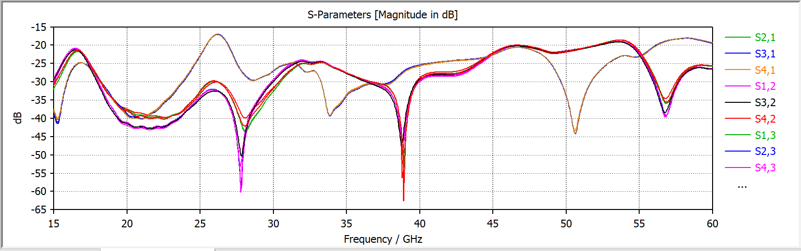

Figure 4: Transmission coefficient v/s Frequency

The figure 3 shows the return loss of the MIMO antenna.The Return loss (S11) is also called reflection coefficient. It is expressed in decibel (dB) and is the ratio of incident to reflected power. For good performance, its value must be minimum of -10 dB or for best case greater than -15 dB[24].We obtained 3 frequencies in mmWave spectrum where S11 was below -15 dB. These are 26.8GHz - 28.2GHz, 33.86-39.08 GHz and 48.2GHz-51.623GHz. The Return losses obtained are -19.15dB at 49.96Ghz with a bandwidth of 2.65Ghz , -17.38dB at 27.55Ghz with a bandwidth of 1.4Ghz and -22.361dB at 35.64Ghz with bandwidth of 5.62Ghz.

The isolation between individual antennas are good (<-20 dB) as shown in figure 4.

1. *VSWR (Voltage standing wave ratio )*

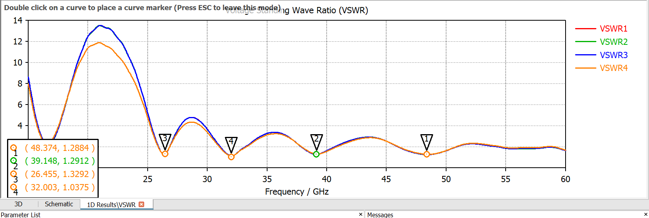

Figure 4 : VSWR v/s Frequency

Reflection of power from the antenna indicated by this value. VSWR must range between 1 to 2 .

From the above figure it can be noted that the VSWR is 1.235 at 25.75 Ghz, 1.319 at 29.625Ghz, 1.0602 at 34.243Ghz and 1.028 at 40.56Ghz.

*C.ECC(Envelope correlation coefficient)*

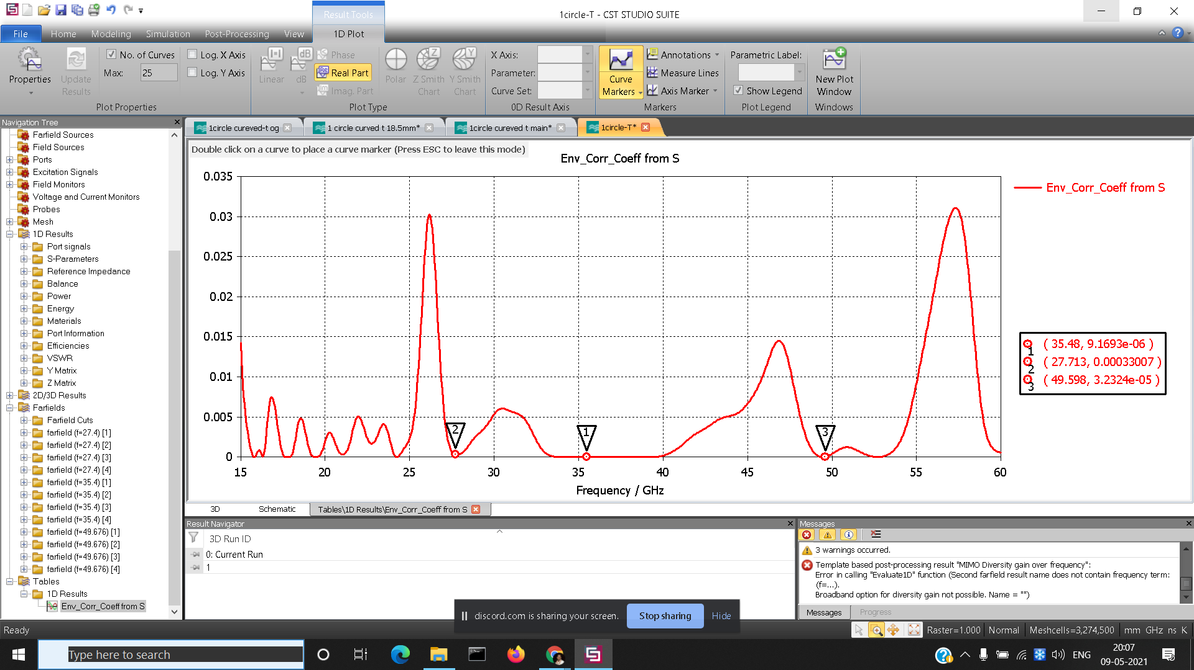

Figure 5:ECC v/s Frequency

In figure 5, the plot of ECC is shown . The Envelope correlation coefficients are 9.69e-6 at 35.48Ghz, 0.0003307 at 27.35Ghz and 3.23e-5 at 49.86Ghz. It is desirable for 5G antennas to have very low ECC. It is a good way to analyze diversity performance of MIMO antenna

*D. Radiation Pattern*

Radiation patterns of all 4 antennas are shown in the figures below at different frequencies.The amount of power radiated by antenna is given by Radiation pattern.We can observe that each antenna at a particular frequency has radiation pattern different from each other. We thus obtain a good ECC for the designed MIMO antenna.

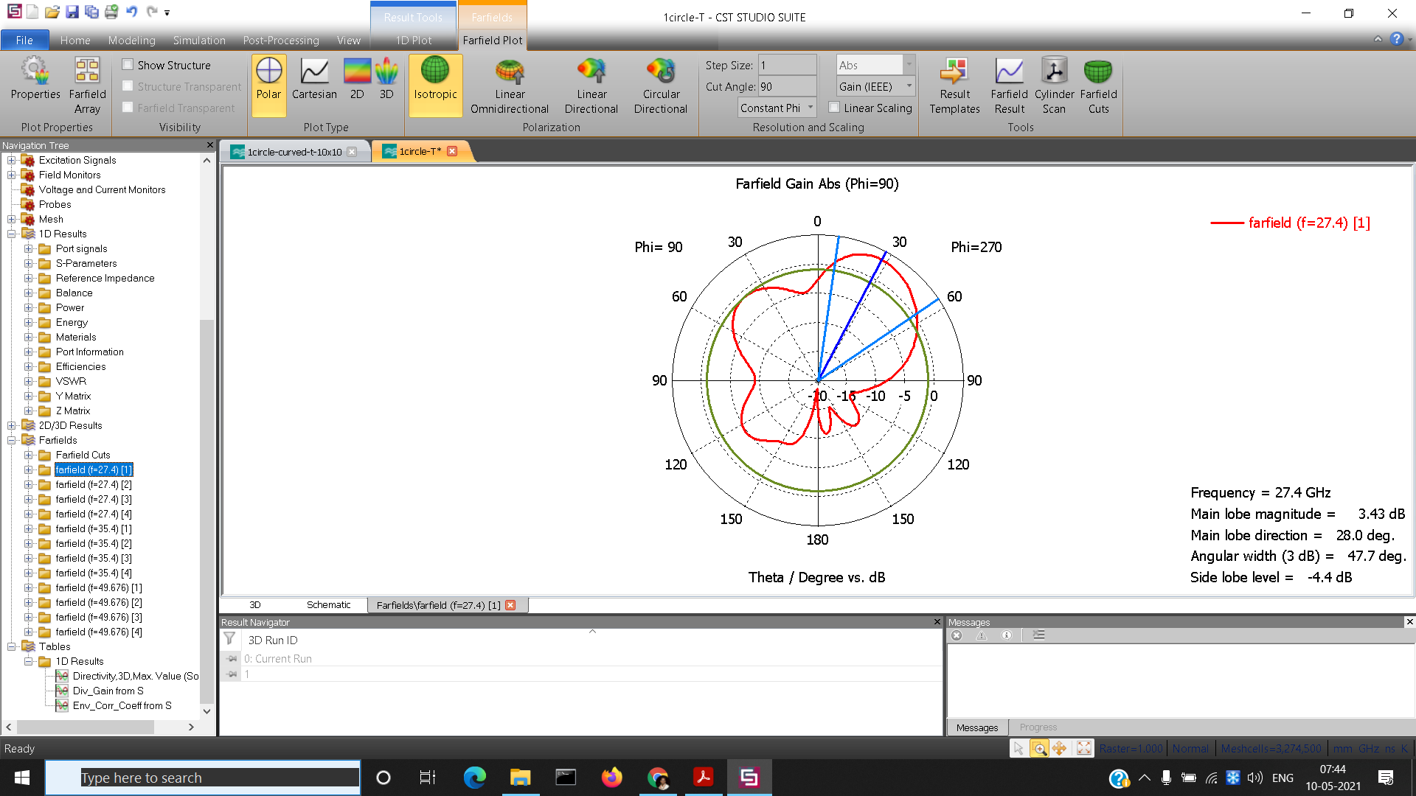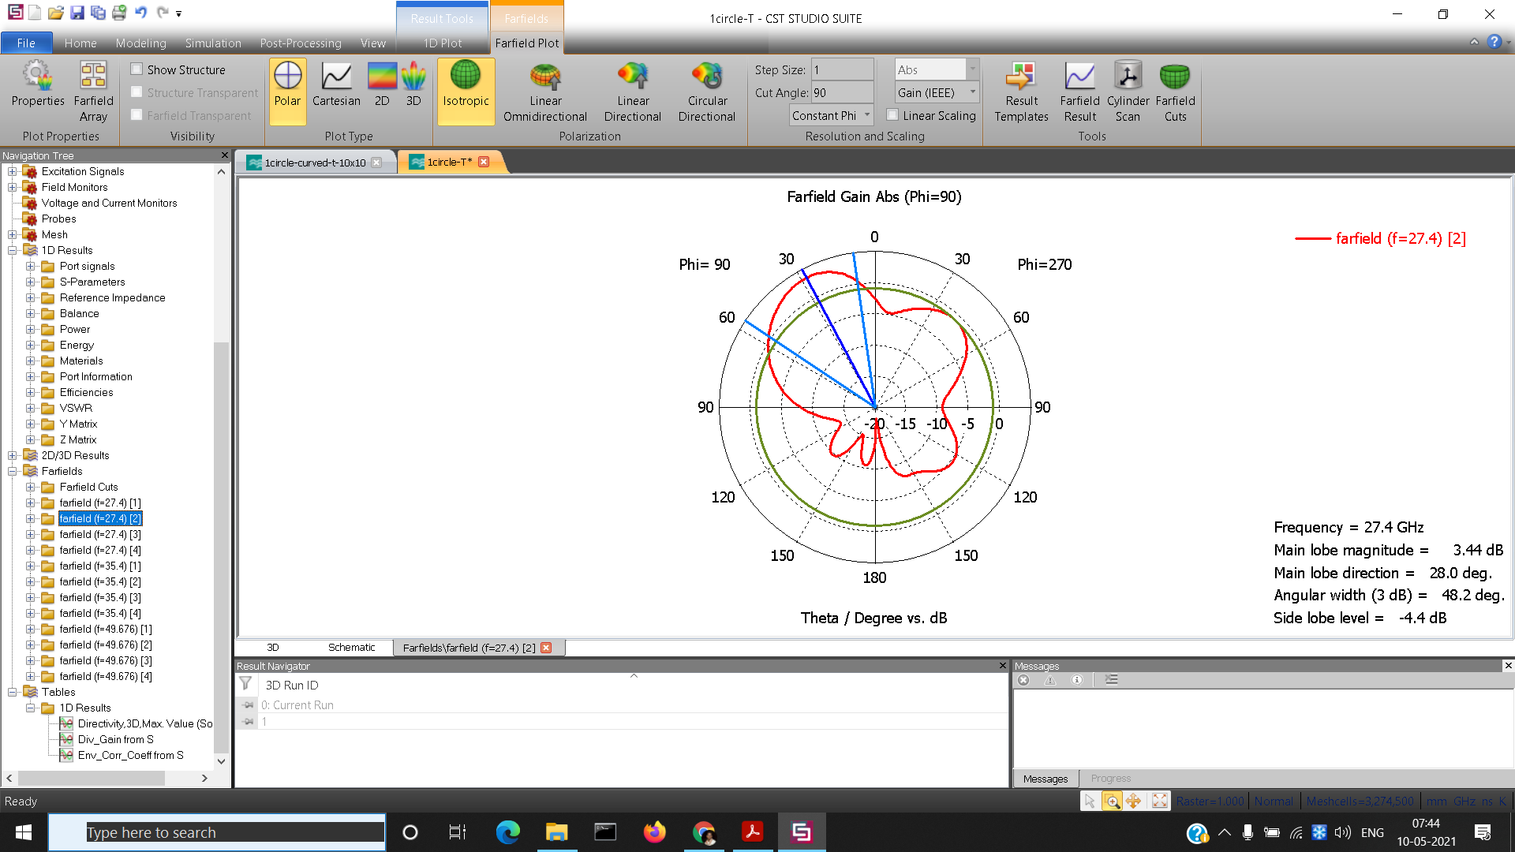

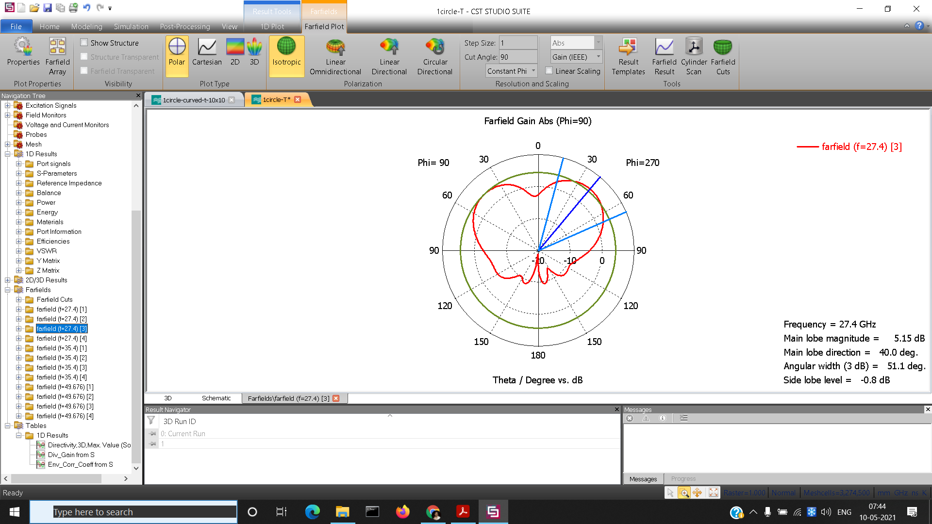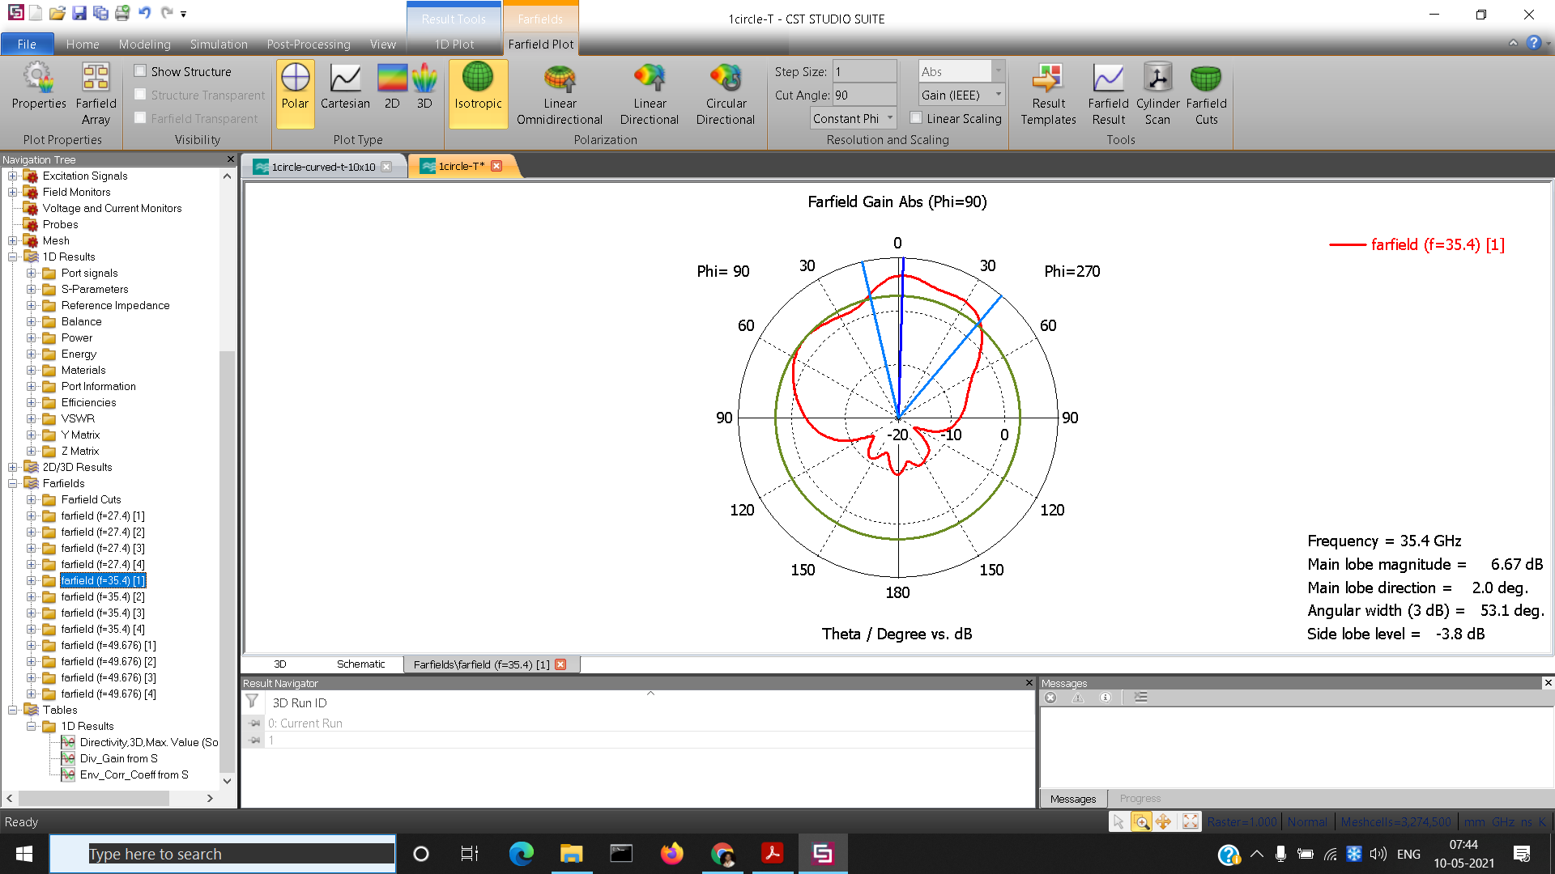

Figure 6:- Radiation pattern at f=27.4 GHz

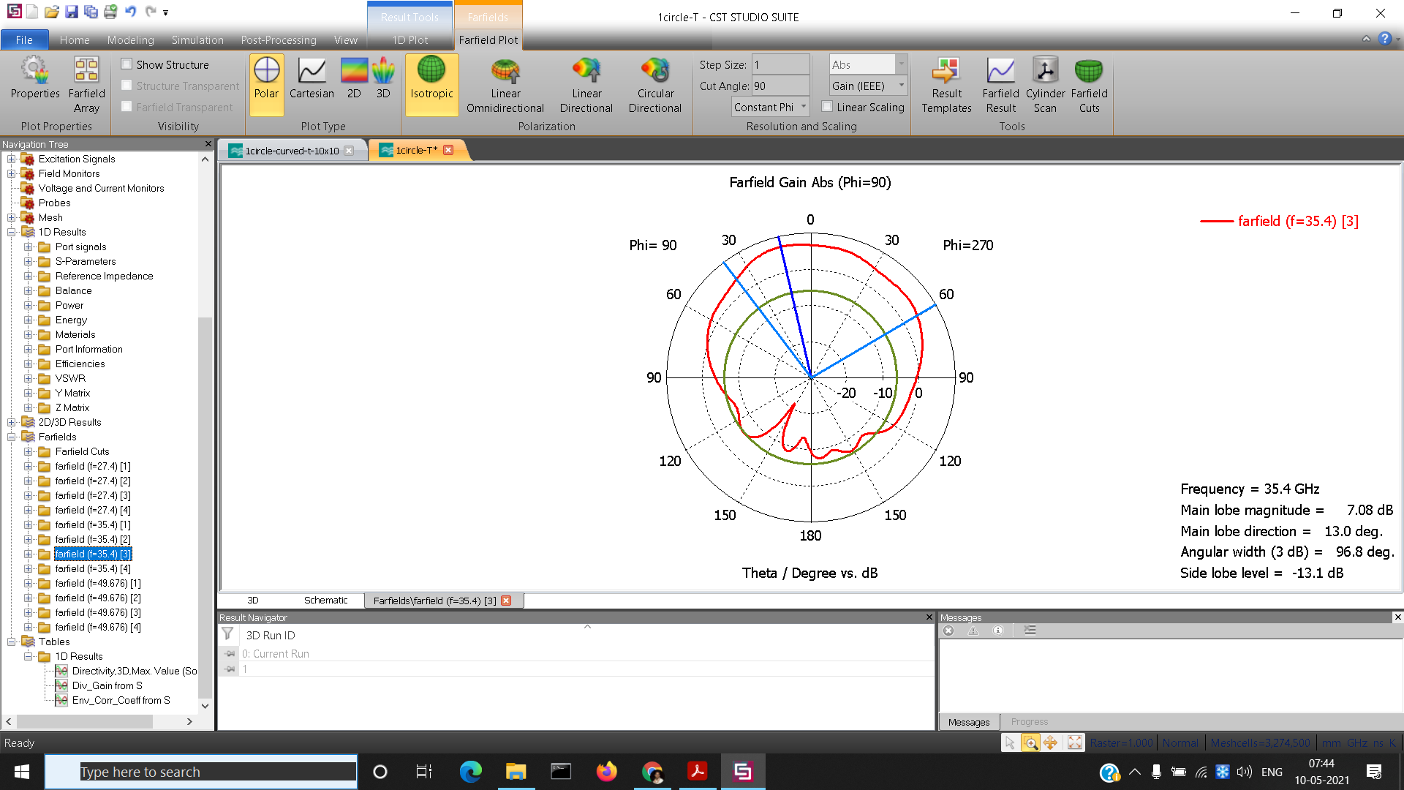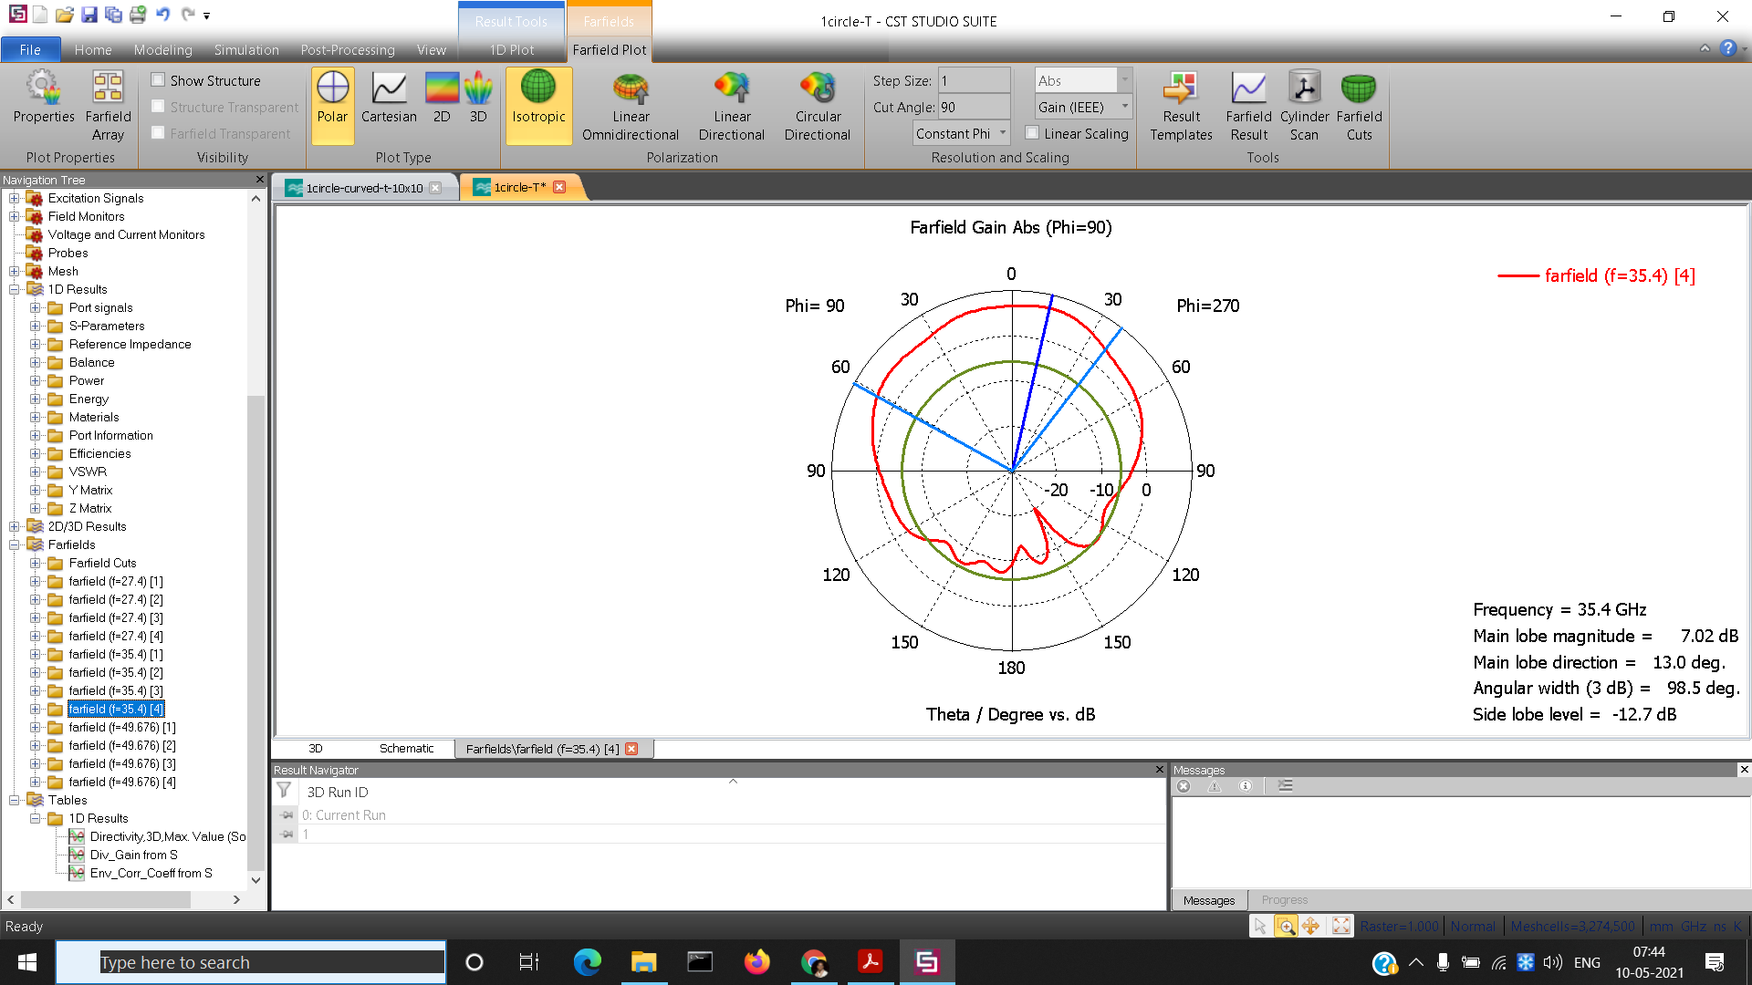

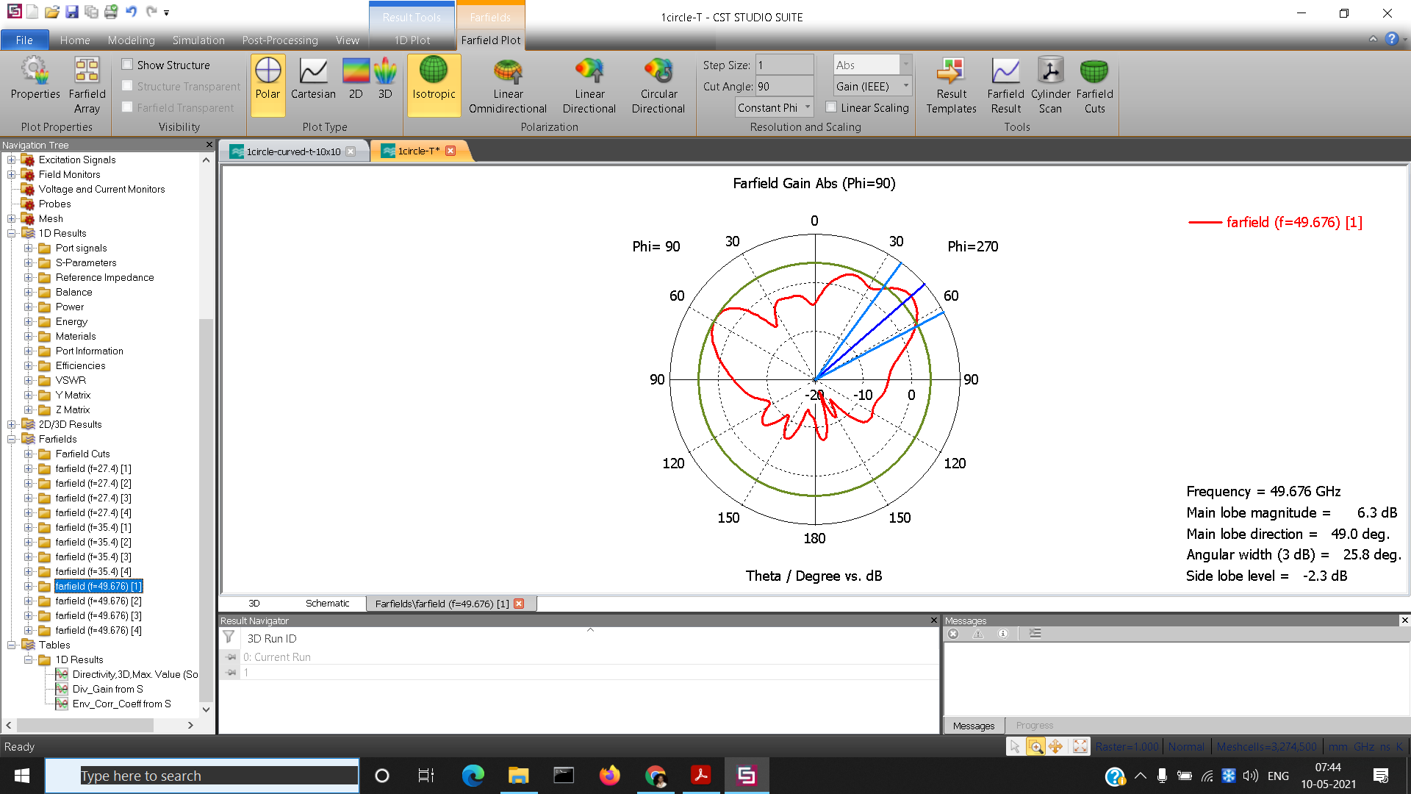

Figure 7:- Radiation pattern at f=35.4 GHz

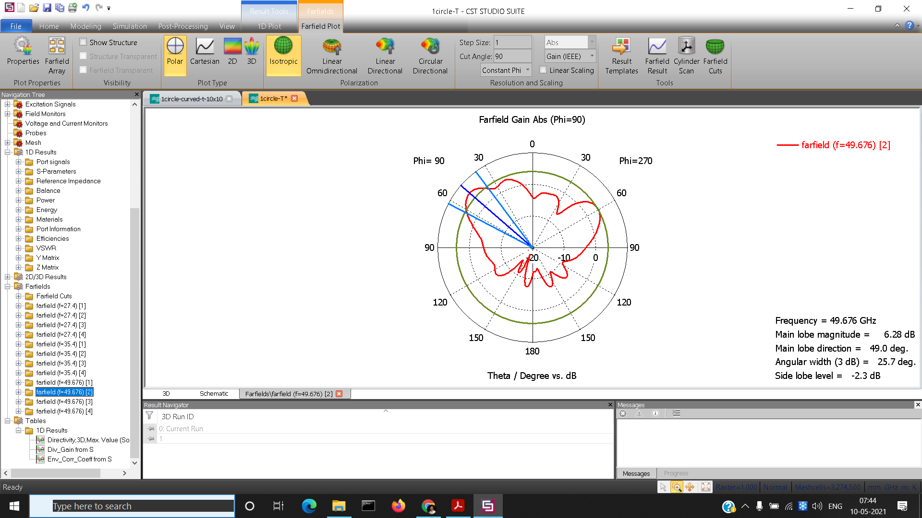

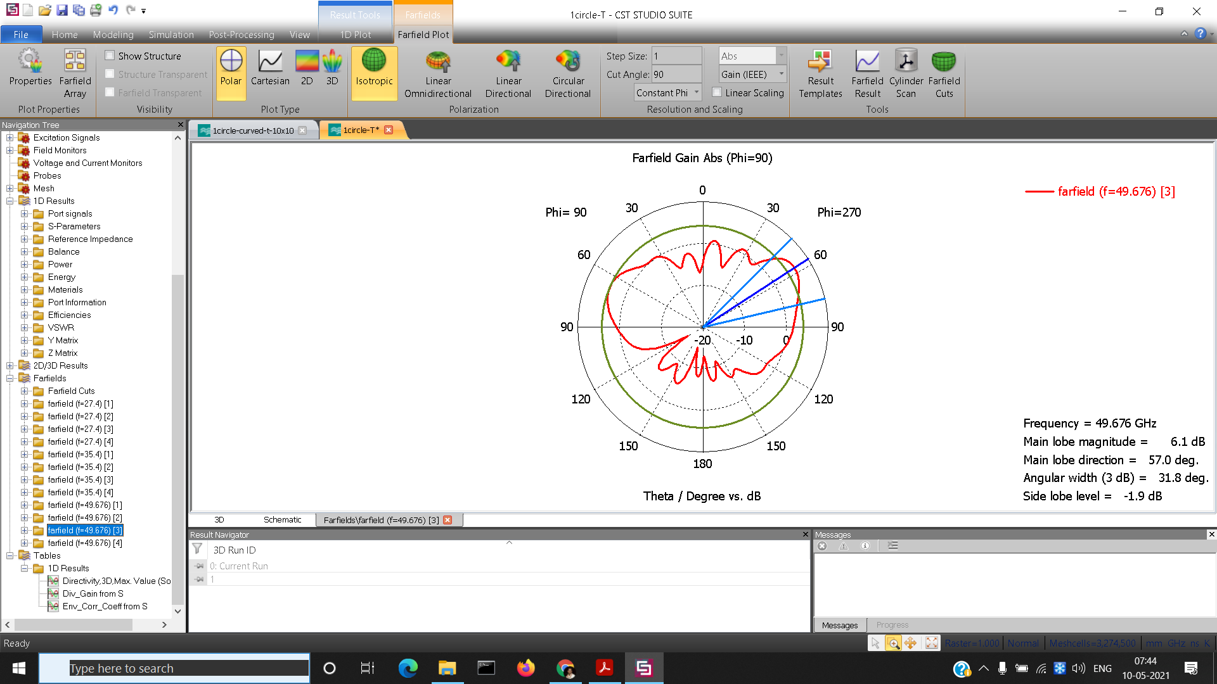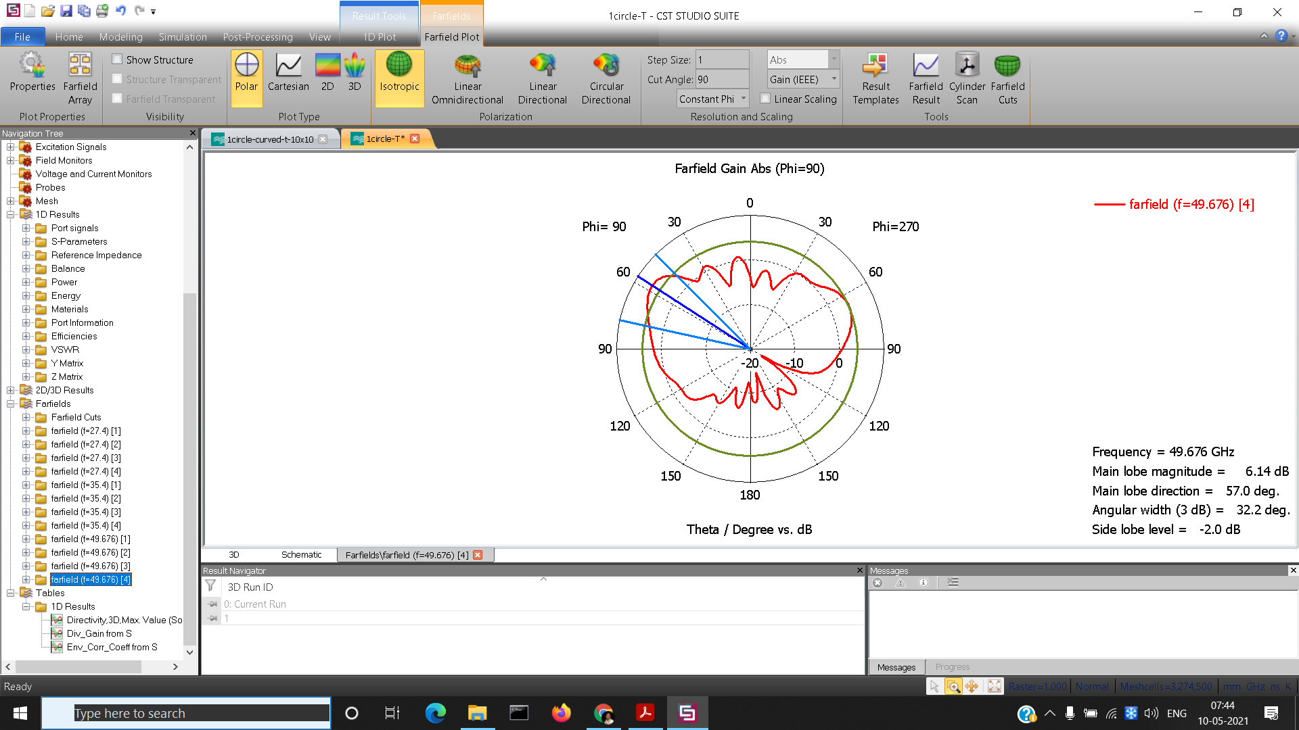

Figure 8:- Radiation Pattern at f=49.676 GHz

| Ref | MIMO | Mm-wave support? | Frequency | Gain  (dbi) | Isolation  (db) | Bandwidth | Both 4G and 5G? | ECC |
| --- | --- | --- | --- | --- | --- | --- | --- | --- |
| [2] | Yes | Yes | 5G - 28GHz, 37 GHz, 39 GHz  4G - 2GHz | 7.2 at mmwave | 25db at mmwave  16db at 2GHz | 5G -  27.5 GHz - 40 GHz | Yes | <0.001 |
| [4] | Yes | Yes | 1870 MHz - 2530 MHz  mmWave - 28 GHz | 3.8dbi | >10db | 1.7 GHz at 28GHz | Yes | <0.5 |
| [12] | Yes | Yes | 25.5 GHz- 29.6 GHz | 8.3 dbi | Below -10db | 3.9 GHz | No | <0.01 |
| [13] | Yes | Yes | 28 GHz | 9.5 dbi | < -30 db | 25GHz- 31 GHz | No | 0.015 |
| [19] | Yes | Yes | WAN - 2.45 GHz GHz, 5.2 GHz  LTE - 2.6 GHz  5G - 24GHz, 28 GHz | 11 dbi | >16db |  | Yes | 0.16 |
| Our Work | Yes | Yes | mmWave - 26.8GHz - 28.2GHz, 33.86-39.08 GHz and 48.2GHz-51.623GHz | 6.16dBi | < -20dB | 26.8-28.2 GHz, 33.86-39.08 GHz, 48.2-51.623 GHz | No | 9.69e-6 at 35.48Ghz, 0.0003307 at 27.35Ghz and 3.23e-5 at 49.86Ghz. |

Table 2.5: Comparison table of MIMO antennas

IV. CONCLUSION

The MIMO antenna proposed in this paper has 4 elements.These 4 are placed opposite to each other for good isolation. On carrying out simulations, we obtain 3 bands of operations. 26.8GHz - 28.2GHz (1.4Ghz ), 33.86-39.08 GHz(5.62Ghz.

) and 48.2GHz-51.623GHz. (2.65Ghz).In these regions the return loss obtained is less than -15dB, which is required for 5G operations.Moreover low value of ECC obtained which indicates good isolation between antennas.

V. REFERENCES

[1] J. G. Andrews, et al, “What Will 5G Be?” IEEE J. Sel. Areas Commun., vol. 32, no. 6, pp. 1065–1082, 2014

[2] Emad Al Abbas, Muhammad ikram, Ahmed Toaha Mobashsher, Amin Abbosh , “MIMO Antenna System for Multi-Band Millimeter-Wave 5G and Wideband 4G Mobile Communications” IEEE Access, vol. 7 , 181916 - 181923,2019

[3] T. S. Rappaport,” Wireless Communications: Principles and Practice” , 2nd ed. Englewood Cliffs, NJ, USA: Prentice-Hall, 2002.

[4] R. Hussain, A. T. Alreshaid, S. K. Podilchak, and M. S. Sharawi, “Compact 4g mimo antenna integrated with a 5g array for current and future mobile handsets,” IET Microwaves, Antennas Propagation, vol. 11, no. 2, pp. 271– 279, 2017.

[5] H. T. Chattha, “4-port 2-element mimo antenna for 5g portable applications,” IEEE Access, vol. 7, pp. 96516–96520, 2019

[6] G. Foschini and M. J. Gans, “On Limits of Wireless Communications in a Fading Environment When Using Multiple Antennas,” Wireless Pers. Commun., vol. 6, no. 3, pp. 311–335, March 1998.

[7] “Estimated spectrum bandwidth requirements for the future development of IMT-2000 and IMT-Advanced,” ITU-R, Geneva, Switzerland, Rep. M.2078, 2006.

[8] Sharawi, M.S. “Printed Multi-Band MIMO Antenna Systems and Their Performance Metrics [Wireless Corner]” . IEEE Antennas Propag. Mag. 2013, 55, 218–232

[9][Leeladhar Malviya](https://ieeexplore.ieee.org/author/37085796769), [Parul Gupta](https://ieeexplore.ieee.org/author/37088334484), [Ajay Parmar](https://ieeexplore.ieee.org/author/37088435908), [Deepak Solanki](https://ieeexplore.ieee.org/author/38232044000), [Priyanshi Malviya](https://ieeexplore.ieee.org/author/37088436297) “MIMO antenna design with low ECC for mmWave”. [IEEE Indian Conference on Antennas and Propagation (InCAP)](https://ieeexplore.ieee.org/xpl/conhome/9130600/proceeding), 2019

[10] [Andrey Tikhomirov](https://ieeexplore.ieee.org/author/37085548148); [Elena Omelyanchuk](https://ieeexplore.ieee.org/author/37085507642); Anastasia Semenova “Recommended 5G frequency bands evaluation” .[2018 Systems of Signals Generating and Processing in the Field of on Board Communications](https://ieeexplore.ieee.org/xpl/conhome/8343065/proceeding), 2018

[11] [Ibra DIOUM](https://ieeexplore.ieee.org/author/37601592000); [Kadidiatou DIALLO](https://ieeexplore.ieee.org/author/37086137776); [Mamadou M. KHOUMA](https://ieeexplore.ieee.org/author/37086506396); [Idy DIOP](https://ieeexplore.ieee.org/author/37085384887); [Lamine SANE](https://ieeexplore.ieee.org/author/37086136536); [Assane NGOM](https://ieeexplore.ieee.org/author/37086508752), “Miniature MIMO Antennas for 5G Mobile Terminals”. [2018 6th International Conference on Multimedia Computing and Systems (ICMCS)](https://ieeexplore.ieee.org/xpl/conhome/8488380/proceeding)

[12] Khalid, M.; Iffat Naqvi, S.; Hussain, N.; Rahman, M.; Mirjavadi, S.S.; Khan, M. J.; Amin, Y. 4-port MIMO antenna with defected ground structure for 5G millimeter wave applications. Electronics 2020, 9, 71.

[13] Niamat Hussain, Min-Joo Jeong, Anees Abbas and Nam Kim,“Metasurface-Based Single-Layer Wideband Circularly Polarized MIMO Antenna for 5G Millimeter-Wave Systems “, IEEE Access

[14] M.Benisha, R.Thangaiah Prabhu, Dr.V.Thulasi Bai,“Requirements and Challenges of 5G Cellular Systems” , [2nd International Conference on Advances in Electrical, Electronics, Information, Communication and Bioinformatics (AEEICB)](https://ieeexplore.ieee.org/xpl/conhome/7529351/proceeding),2016

[15][Youssef El Gholb](https://ieeexplore.ieee.org/author/37085455490); [Najiba El Amrani El Idrissi](https://ieeexplore.ieee.org/author/37086127638) “ 5G Mobile Antennas: MIMO Implementation”.[International Conference on Wireless Technologies, Embedded and Intelligent Systems (WITS)](https://ieeexplore.ieee.org/xpl/conhome/8713414/proceeding), 2019

[16] Constantine A. Balanis, “Antenna Theory-analysis and design”. A John Wiley & sons, inc., pp.811-876, 2005.

[17] . K.R.Carver and J.W.Mink, “Microstrip Antenna Technology” IEEE Trans. Antennas Propagat., Vol. AP29, No. 1, pp. 2–24, January 1981

[18] International Telecommunication Union. Minimum requirements related to technical performance for IMT-2020 radio interface(s), 2017, vol. 0, p. 9.

[19] [Muhammad Ikram](https://ieeexplore.ieee.org/author/37664072900); [Nghia Nguyen-Trong](https://ieeexplore.ieee.org/author/37060988500); [Amin Abbosh](https://ieeexplore.ieee.org/author/37297192800)” Multiband MIMO Microwave and Millimeter Antenna System Employing Dual-Function Tapered Slot Structure”,[IEEE Transactions on Antennas and Propagation](https://ieeexplore.ieee.org/xpl/RecentIssue.jsp?punumber=8), vol 67 , pp 5705 - 5710,2019

[20][Souhir Faleh](https://ieeexplore.ieee.org/author/37086253368); [Jamel Belhadj Tahar](https://ieeexplore.ieee.org/author/38561120900) “Optimization of a new structure patch antenna for MIMO and 5G applications”,[25th International Conference on Software, Telecommunications and Computer Networks (SoftCOM)](https://ieeexplore.ieee.org/xpl/conhome/8106909/proceeding) , 2017.

[21]E. Yaacoub, M. Husseini and H. Ghaziri, "An overview of research topics and challenges for 5G massive MIMO antennas," 2016 IEEE Middle East Conference on Antennas and Propagation (MECAP), Beirut, 2016, pp. 1-4, doi: 10.1109/MECAP.2016.7790121.

[22] P. M. Sunthari and R. Veeramani, "Multiband microstrip patch antenna for 5G wireless applications using MIMO techniques," 2017 First International Conference on Recent Advances in Aerospace Engineering (ICARE), Coimbatore, 2017, pp. 1-5, doi: 10.1109/ICRAAE.2017.8297241.

[23]Constatine. E. Balanis, “Antenna Theory: Analysis and Design, 3rd Edition - Constantine A. Balanis,” Book. 2005. [24]Mohammad Faisal, Abdul Gafur, Syed Zahidur Rashid, Md.OmarFaruk Shawon, Kazi Ishtiak Hasan and Md.Bakey Billah, “Return Loss and Gain Improvement for 5G Wireless Communication Based on Single Band Microstrip Square Patch Antenna”, 1st International Conference on Advances in Science, Engineering and Robotics Technology (ICASERT 2019), Dhaka, Bangladesh,2019.

[24]Mohammad Faisal, Abdul Gafur, Syed Zahidur Rashid, Md.OmarFaruk Shawon, Kazi Ishtiak Hasan and Md.Bakey Billah, “Return Loss and Gain Improvement for 5G Wireless Communication Based on Single Band Microstrip Square Patch Antenna”, 1st International Conference on Advances in Science, Engineering and Robotics Technology (ICASERT 2019), Dhaka, Bangladesh,2019.